
Sec 5.8 – Trigonometry & Regression
Linear Regression Models Name:

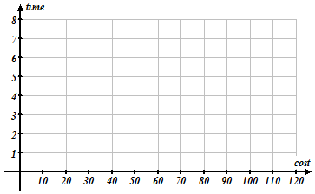
- Create a scatter plot and approximate a trend line of best fit based on the data below
Model | Cost of Car | 0-60 mph  acceleration
Scion xB | $16 K | 7.8 sec
Mitsubishi Eclipse | $24 K | 6.1 sec
Chev. Corvette | $106 K | 3.4 sec
Nissan GT-R | $76 K | 3.5 sec
SSC Ultimate Aero | $42 K | 4.8 sec
Lotus Elise | $60 K | 4.4 sec
Honda Civic Si | $22 K | 6.7 sec

Using your trend line, predict the 0-60 time for a car that costs $120 K?

- Consider the following scatter plots:
______strong positive correlation ______weak positive correlation _______strong negative correlation ______weak negative correlation

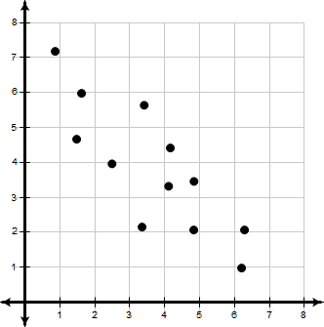
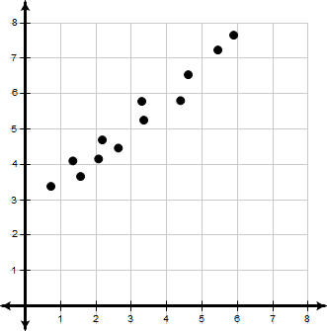
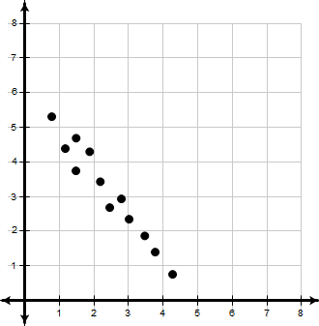
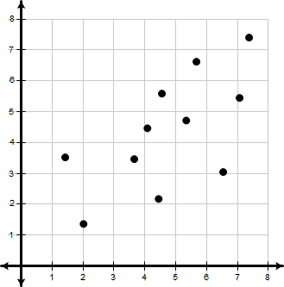
D
C
A
B

- Consider the following situations. Determine whether you think they have a positive or negative correlation.
  - Usually as a car increases in age, its value decreases.

  - Usually the more hours that a person works the larger their paycheck.

  - Usually the younger a child is, the smaller their height.

  - Usually the longer you use a smart phone, the amount of battery life decreases.

- Consider the following situations and answer the following True or False Questions.
A researcher noticed a relatively strong positive correlation between a student’s score on the SAT and their GPA at the high school they attend.

  - If one student has one of the lower SAT scored at one high school then they probably have one of the higher GPA’s at their school.

  - If one student has the highest SAT score at one high school then they must have the highest GPA at their high school too.

  - If one student has one of the higher SAT scores at one high school then they probably have one of the higher GPA’s at their school.

Student Worksheets Created by Matthew M. Winking at Phoenix High School SECTION 5-8 p.72

- Most trend lines that are considered to be a “good fit” will be balanced such that the total RESIDUAL above and below the trend line is equal. RESIDUAL can be defined as the difference between the actual value (y) and expected value$(\hat{y})$. A more succinct definition, RESIDUAL can be described as the vertical distance each data point is away from the trend line (with signed difference for above and below the trend line).

Find the RESIDUALs for each of the TREND LINES below (the SCATTER PLOT is the same in each graph).

TREND LINE 2
TREND LINE 1
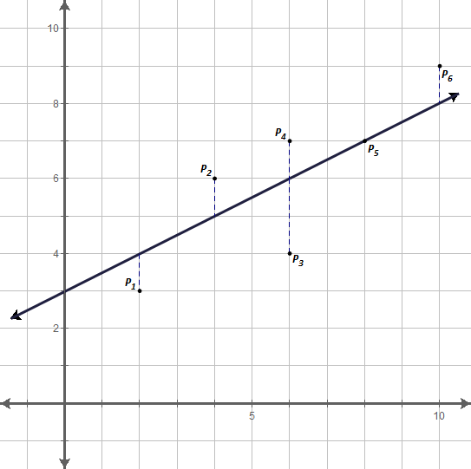
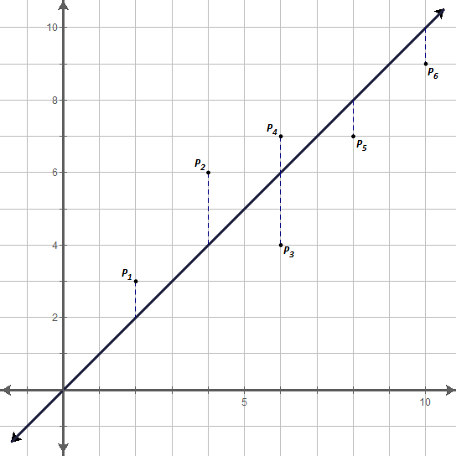
Data Point | Residual
P₁ | 1
P₂ | 2
P₃ | –2
P₄
P₅
P₆
Sum of Residuals

Data Point | Residual
P₁
P₂
P₃
P₄
P₅
P₆
Sum of Residuals

2
-2

1

TREND LINE 4
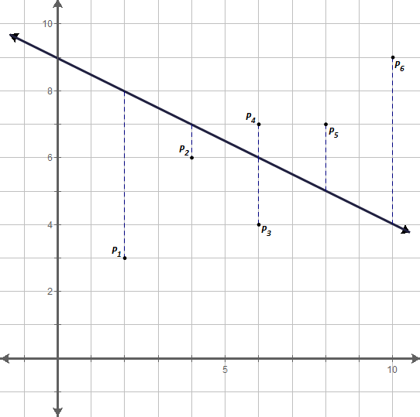
Data Point | Residual
P₁
P₂
P₃
P₄
P₅
P₆
Sum of Residuals

TREND LINE 3
Data Point | Residual
P₁
P₂
P₃
P₄
P₅
P₆
Sum of Residuals

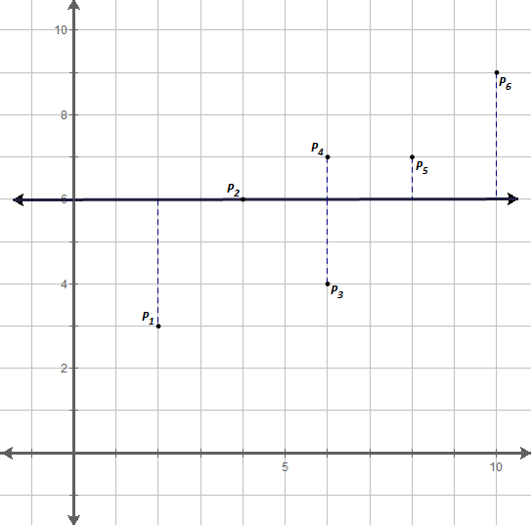

- What do all 4 trend lies above have in common? (optional: what is the approximate residual of your trend line from earlier)

- To better analyze which trend line is best, it is common to consider comparing the sum of the squares of the residuals. Which trend line do you think is the best based on this new information? Is it the one you expected?
TREND LINE 1
Data Point | Residual | Residual Squared
P₁
P₂
P₃
P₄
P₅
P₆
Sum

Data Point | Residual | Residual Squared
P₁ | 1 | 1
P₂ | 2 | 4
P₃ | –2 | 4
P₄
P₅
P₆
Sum

TREND LINE 4
TREND LINE 3
TREND LINE 2
Data Point | Residual | Residual Squared
P₁
P₂
P₃
P₄
P₅
P₆
Sum

Data Point | Residual | Residual Squared
P₁
P₂
P₃
P₄
P₅
P₆
Sum

Student Worksheets Created by Matthew M. Winking at Phoenix High School SECTION 5-8 p.73

- The line that minimizes the squares is called the LEAST SQUARES REGRESSION LINE. Most scientific calculators are capable of determining the equation of this trend line. Consider again the data about the cars. The following are the directions for the TI-83/84:
Model | Cost of Car | 0-60 mph  acceleration
Scion xB | $16 K | 7.8 sec
Mitsubishi Eclipse | $24 K | 6.1 sec
Chev. Corvette | $106 K | 3.4 sec
Nissan GT-R | $76 K | 3.5 sec
SSC Ultimate Aero | $42 K | 4.8 sec
Lotus Elise | $60 K | 4.4 sec
Honda Civic Si | $22 K | 6.7 sec

- First, it will be helpful to turn on additional diagnostic information in your calculator.
SCROLL DOWN TO DianosticOn
CATALOG
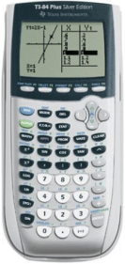
…….…

- Under the Stat menu, press.
(This just resets the list menus)

- Next, press

- If there is OLD data already in the lists that needs to be cleared press the up arrow, , to highlight L1 and then press to clear out the old data. Do the same for L2 if it has OLD data that needs to be cleared.
To clear out OLD data, first highlight L1 and press CLEAR, ENTER.

0-60 time
Car Cost


- Next, enter the Cost of the Car in L1 and the 0-60 mph time in L2.
$$

- Return to the home screen by pressing and then to calculate the linear regression press .

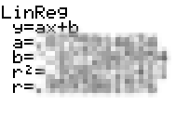
- This represents the an equation of a line that minimizes the total residuals squared.

Fill in the blanks to complete the LEAST SQUARES REGRESSION LINE equation.

y = •x +
b
a

Use this equation to reattempt your prediction of how fast a car can go from 0-60mph that costs $120 K

y = •(120) + =
a
b

- When a prediction is made between two given data points the prediction is called an INTERPOLATION. When a prediction is made outside the range of given data points the prediction is an EXTRAPOLATION. Which type of prediction was used when you predicted the 0 – 60 mph time of a car that cost $120 K?

- A calculation called the correlation coefficient (r) is used to measure the extent to which the data for the two variables show a linear relationship. The closer the value is to 1 or –1 the stronger the linear relationship. Describe the relationship of the car data.
Weak
Strong
None
Weak
Strong
r:
0
Perfect
Positive
Linear
Relationship
No
Linear
Relationship
Perfect
Negative
Linear
Relationship

Student Worksheets Created by Matthew M. Winking at Phoenix High School SECTION 5-8 p.74

